**CREATE NODE-RED SERVICE**

|  |  |
| --- | --- |
| **TEAM ID** | PNT2022TMID16047 |
| **PROJECT NAME** | Hazardous area monitoring for industrial plant powered by IOT |
| **MAXIMUM MARKS** | 4 |

**STEPS**:

1. Create an IBM Cloud account and login to the respective account

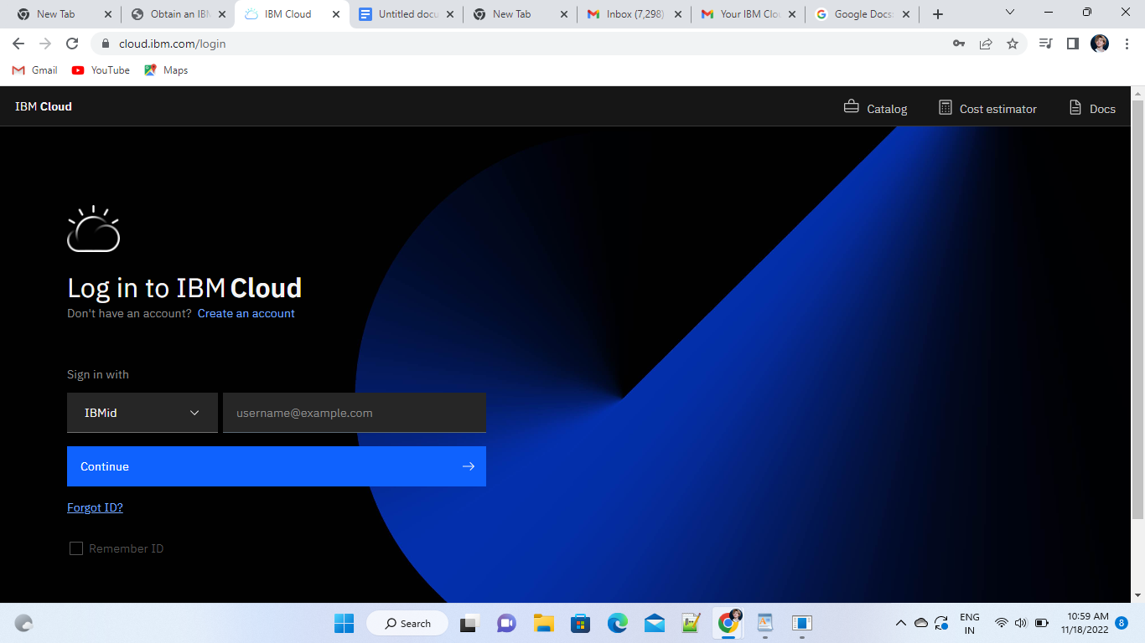

1. Dashboard of the IBM Cloud

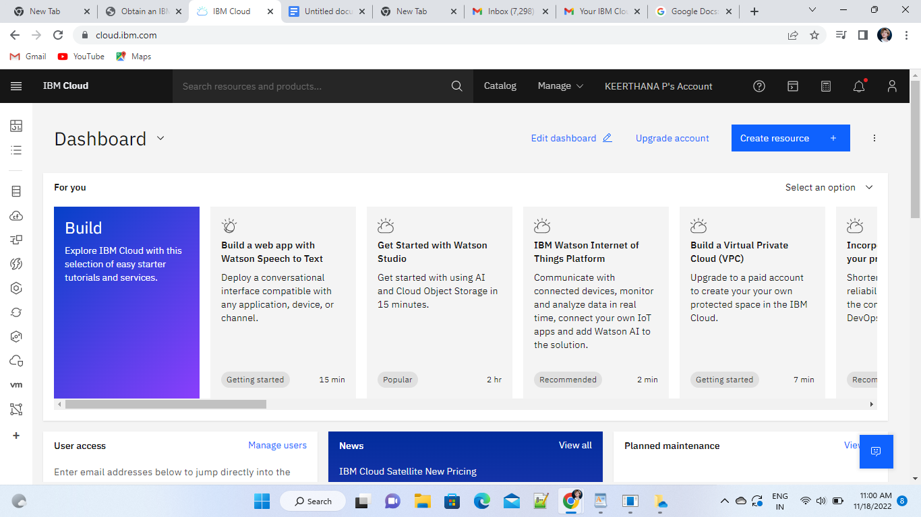

1. Click on the catalog on the top right. And search for NODE RED APP

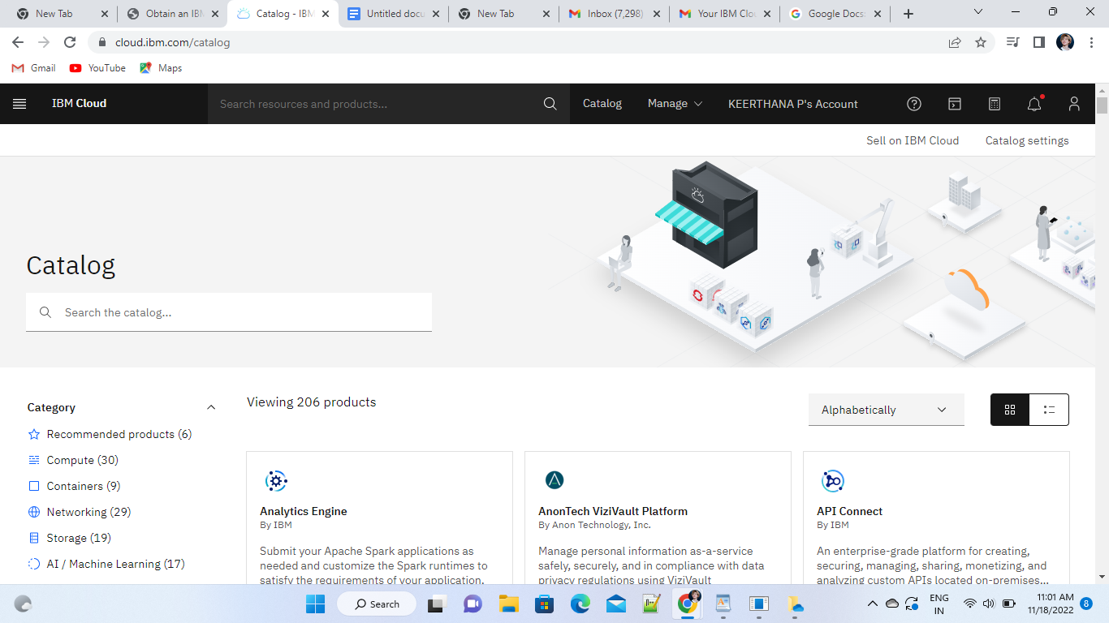

1. Node Red page appears on the screen

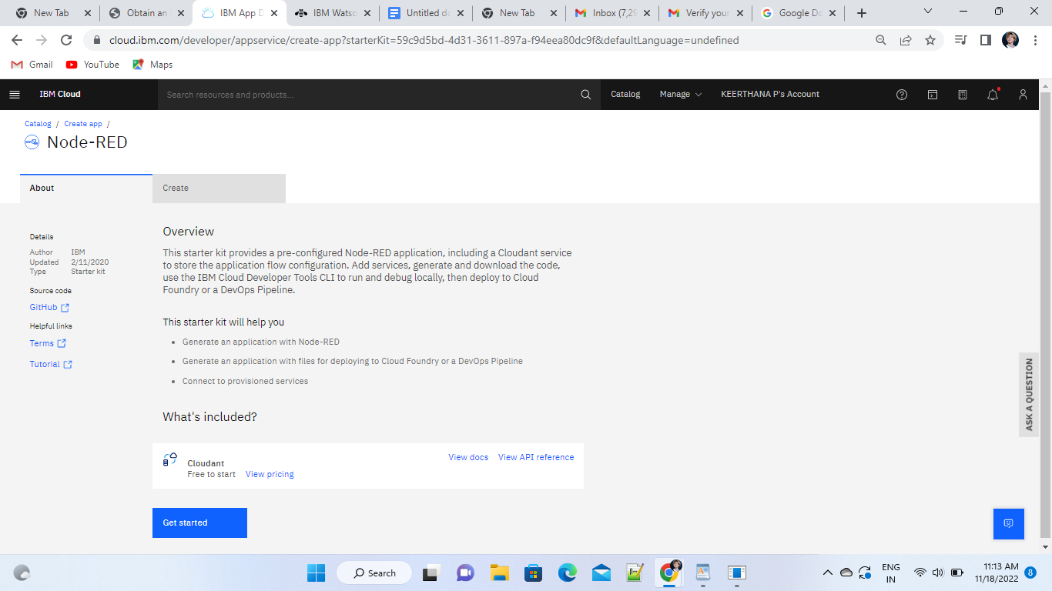

1. Enter the app details

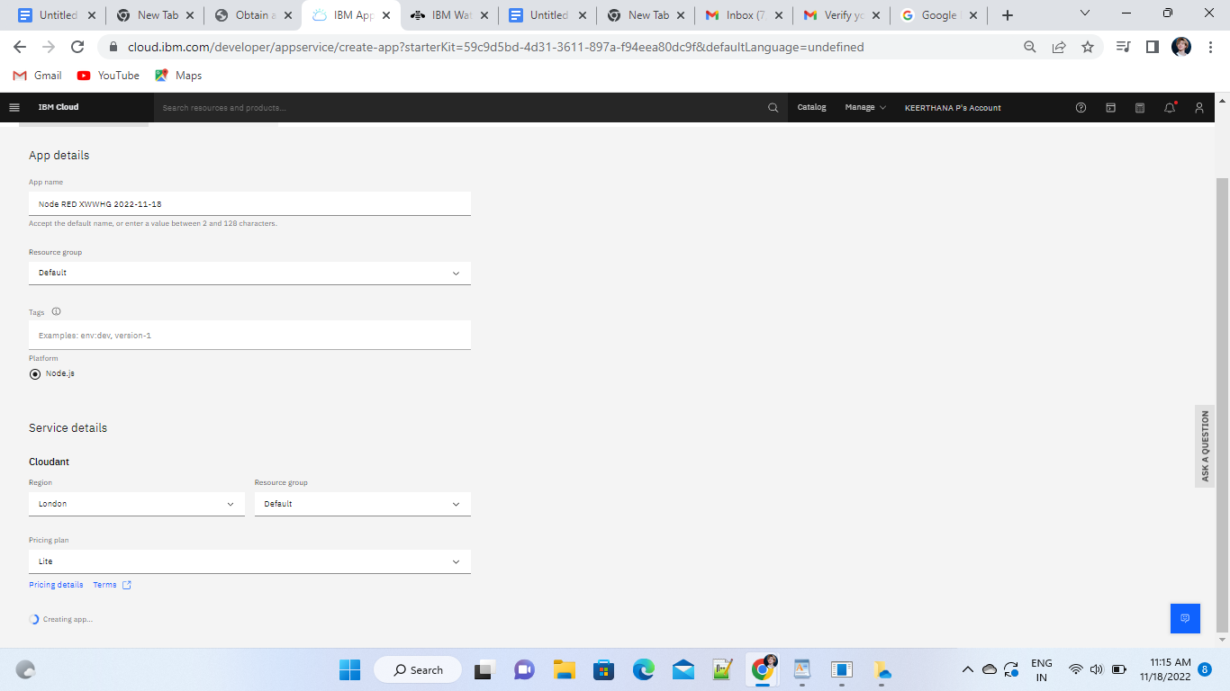

1. Click the “deploy your app”

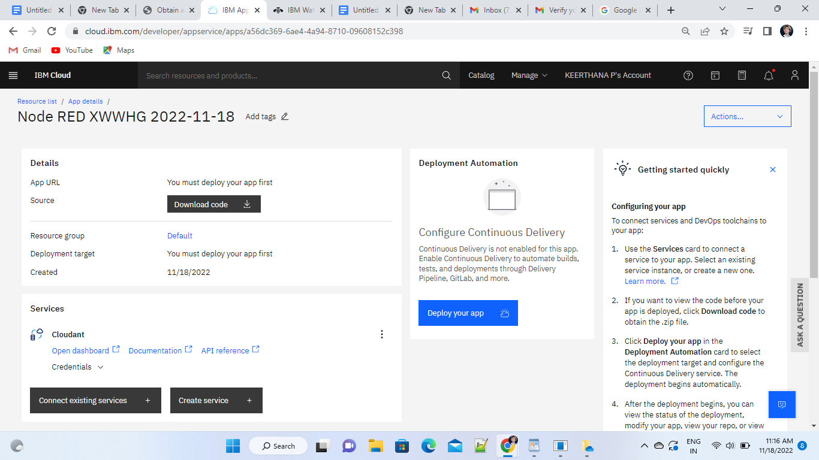

1. Set up the environment and deploy the app

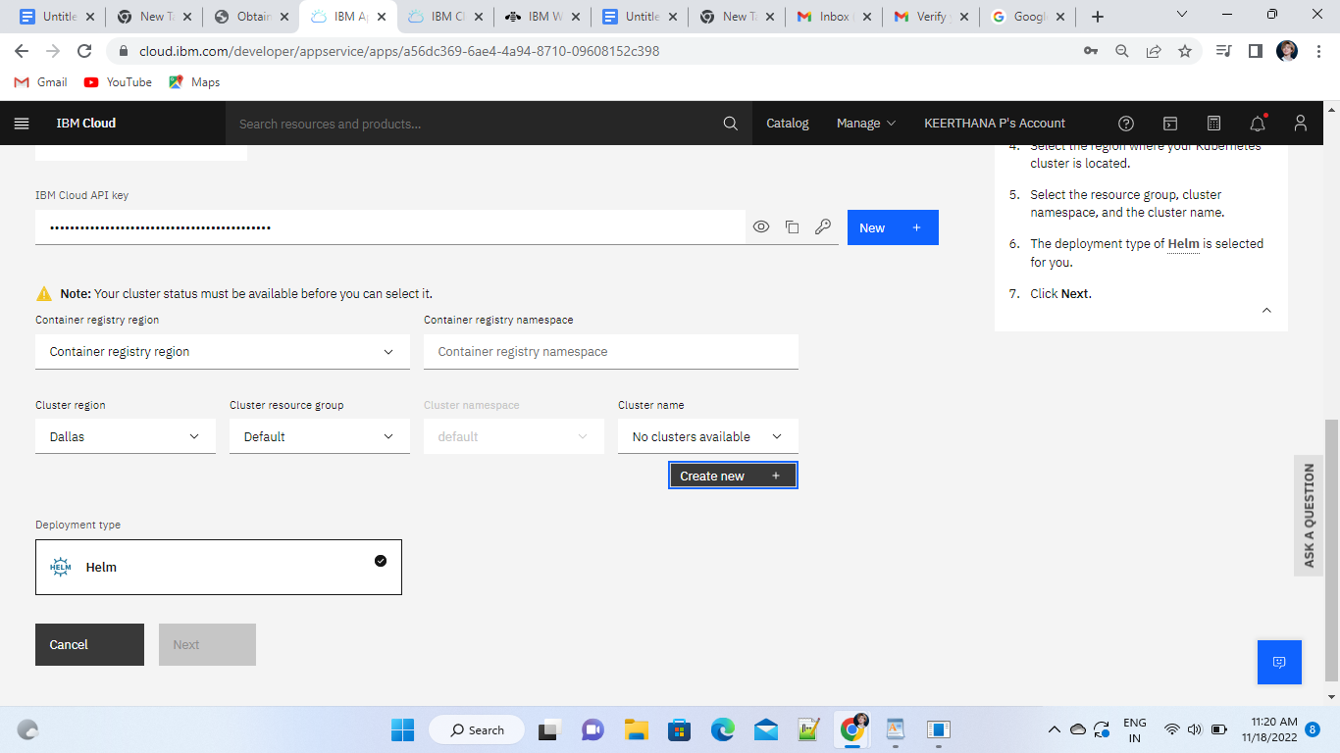

1. The app is deployed successfully

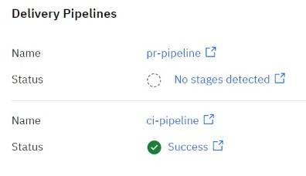

1. Components are dragged and placed in the editor

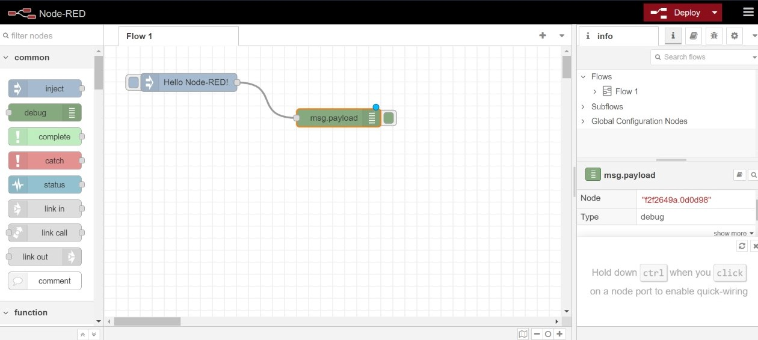

10. Enter the required details in the properties

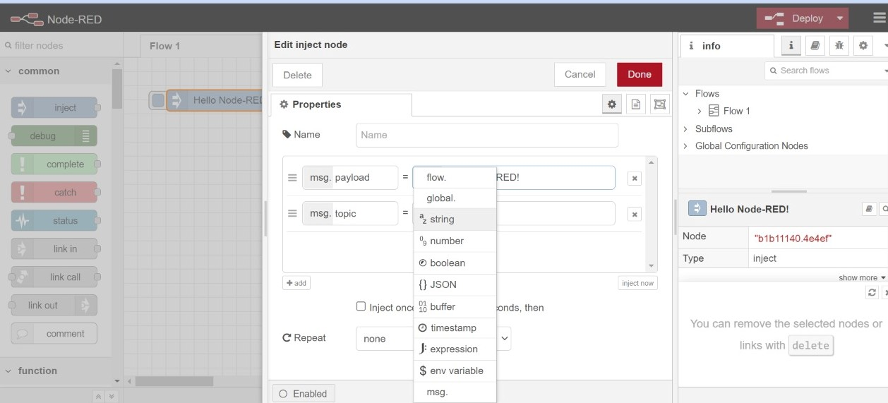

11. The Node Red App is successfully deployed

